**Unit 6 Similarity Performance Task**

Below is a map of Mott Haven. Find and label the following points:

|  |  |
| --- | --- |
| * East 149th St & Third Ave is point M * East 139th St & Willis Ave is point N * East 139th St & Third Ave is point O | * East 143rd St & Third Ave is point P * East 143rd St & Willis Ave is point Q * East 139th St & Alexander Ave is point R |

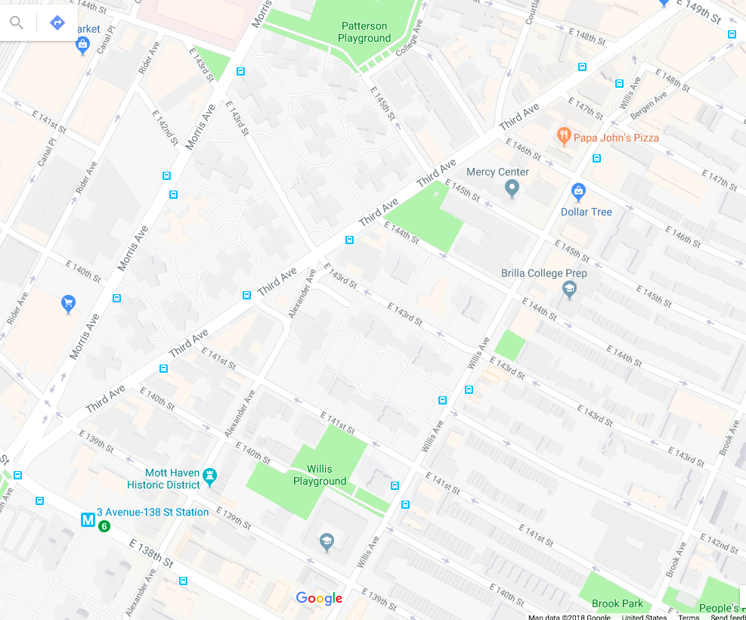

*Use this map to answer the questions on the back side of this sheet. Explain every step of your thinking and mathematical process, and attach any additional work you completed on loose leaf paper.*

**Part 1: Understanding the Context**

1. What assumptions about the real world can you make to solve this problem?

*As you make these assumptions, annotate your diagram (i.e. mark angles, sides etc.)*

* 1. Do you see any lines that look parallel?
  2. Why would it be reasonable and helpful to assume they are parallel?
  3. Do you see any angles that look like right angles?
  4. Why would it be reasonable and helpful to assume they are right angles?
  5. Name all triangles on the map now that you have points M, N, O, P, Q, and R. What do you notice about these triangles?
  6. The average North to South city block (i.e. 138th st to 139th st) measures 264 feet, but not every city block measures 264 feet. Why is it both reasonable and helpful to use the average block length in your model?
  7. Why do mathematicians assume things to make sense of the real world?

1. Do you see any triangles that could be considered similar? Which triangle similarity rule can be used **and** why?

**Part 2: Calculation & Reasoning**

*Show all your work on the attached process page!*

Each NYC block that runs North to South measures on average 264 feet. For example, the distance between East 141st street and East 140th street is 264 feet.

1. Given that the length of ON is 1250 feet, what is the length of East 143rd St between Third Ave and Willis Ave ($\overline{PQ}$)? *Show all work and explain it in at least one sentence.*
2. What is the length of East 139th St between Third Ave and Alexander Ave ($\overline{OR}$)? *Show all work and explain it in at least one sentence.*

**Part 3: Process**

*Explain every step of your thinking and mathematical process, and attach any additional work you completed on loose leaf paper.*

**Introduction:**

1. What is the goal of this task? What are you solving for?

2. What strategies or concepts have you learned in this class that helped you to solve this problem? How did you use those strategies to complete the task?

**Analysis:**

3. What does it mean for two triangles to be similar? How does this task relate to triangle similarity?

4. What calculations did you make to solve this problem? Explain in detail your process.

**Reflection:**

5. Do you believe that the solutions you found are 100% accurate? What are some factors (including real-world considerations) that might contribute to this? Is the model still valid?

6. Discuss one real-world application for which this data would be useful and one for which it is not accurate enough. (For example, this data would NOT be accurate enough to design a sidewalk that is exactly between Third Ave and Willis Ave on 143rd St).

**Unit 6 Similarity Performance Task Rubric**

|  |  |  |  |  |
| --- | --- | --- | --- | --- |
|  | **4** | **3** | **2** | **1** |
| **Part 1: Understanding the Context**  Comprehension of the real world context is evident. | Explanations are in complete sentences and make explicit connections to the map. | Explanations are in complete sentences but may not make explicit connections to the map. | Explanations are not in complete sentences and do not make explicit connections to the map. | Work is missing or plagiarized. |
| **Part 2: Calculation and Reasoning**  Calculations are set up and executed correctly. | Calculations are completely accurate and described with precise mathematical language. | Calculations are mostly accurate but not described with precise mathematical language. | Calculations are not accurate and not precisely described in mathematical language. | Work is missing or plagiarized. |
| **Part 3: Process**    Connections are made between the real world context and the similarity unit. | Explanations are detailed and connections are clear between the task and the real world context. | Explanations are mostly detailed but connections are not always clear between the task and the real world context. | Little to no effort has been put into the explanations and no connections have been made. | Work is missing or plagiarized. |

**Rubric Score: _________ / 12 Converted Score: __________ / 100**